
Touchstones Project
Netcards

Reconciliation Netcards with Text

Black Lives Matter HRJ
Chalice HRJ
Church HRJ
Civil Rights HRJ

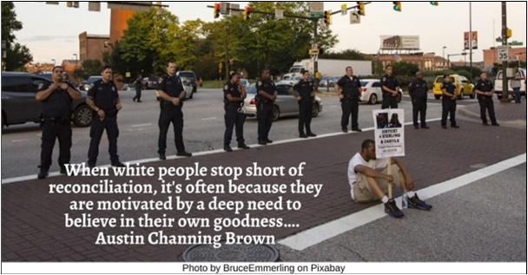

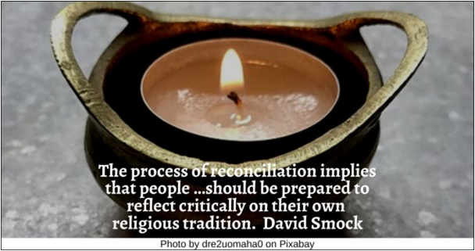

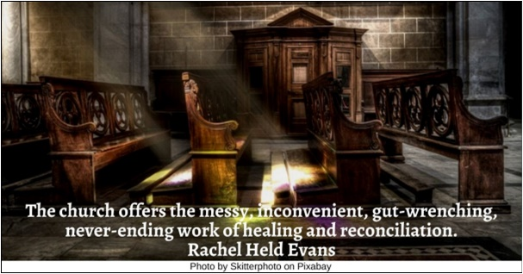

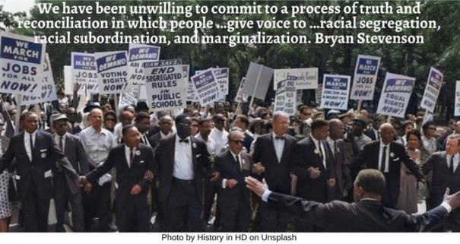

Couple HRJ
Dove HRJ
Equals HRJ
Fewer Quarrels HRJ

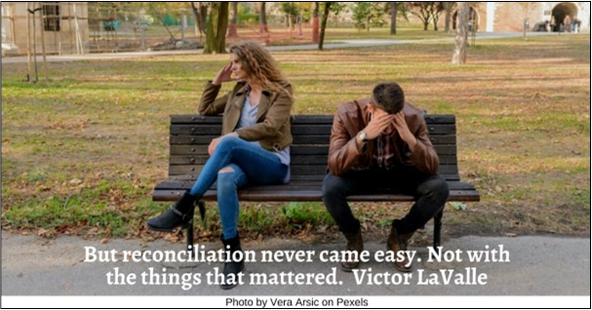

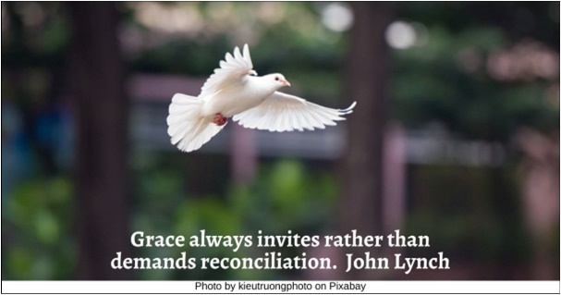

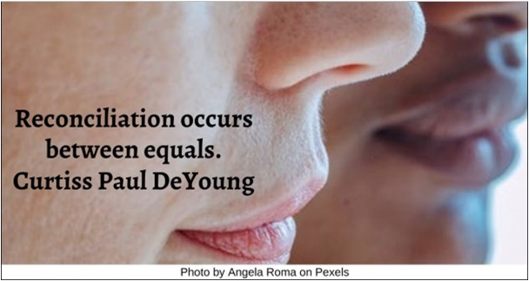

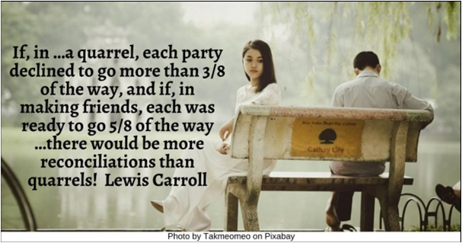

First Nations HRJ
Forgiveness HRJ
Hand Reaching HRJ
Hands Over Eyes HRJ

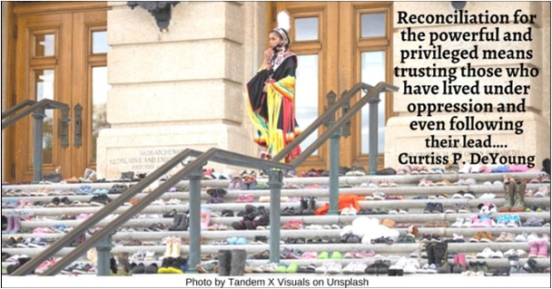

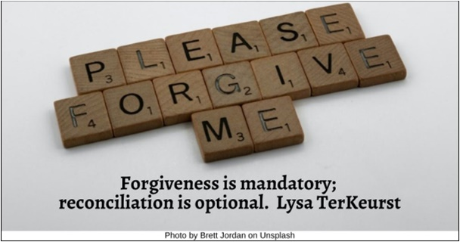

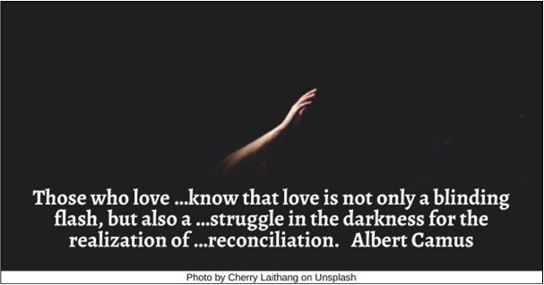

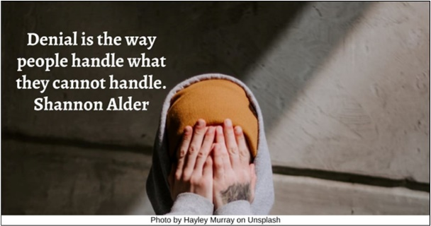

Harbor HRJ
Homeless HRJ
John Lewis HRJ
Journey HRJ

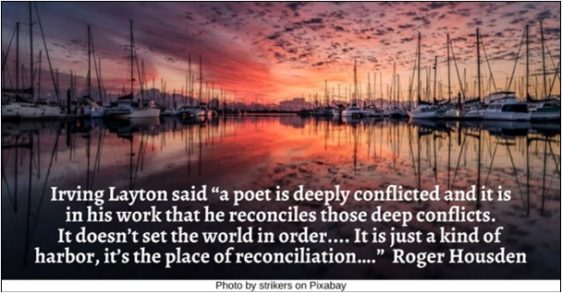

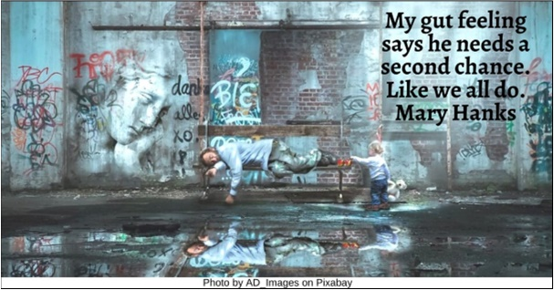

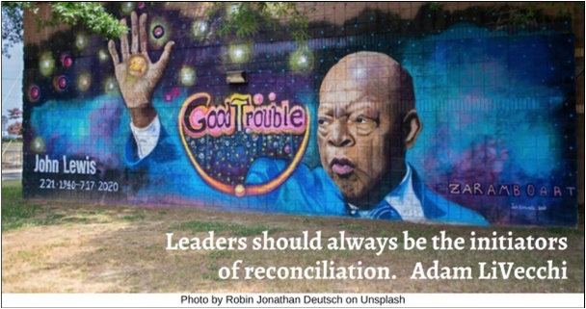



Martin Luther King Jr HRJ
Meditation HRJ
No HRJ
Nonviolence HRJ

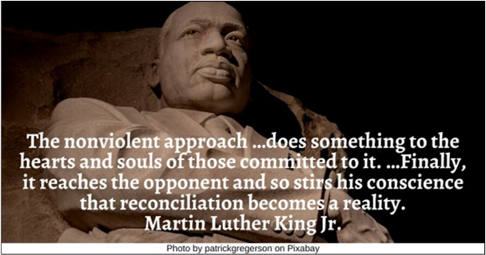

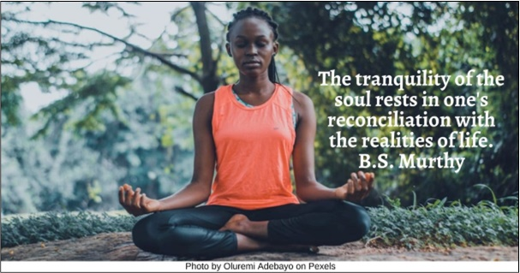



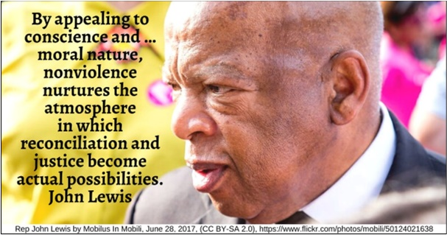

Old Photographs HRJ
Reconciliation HRJ
Roads HRJ
Self-care HRJ

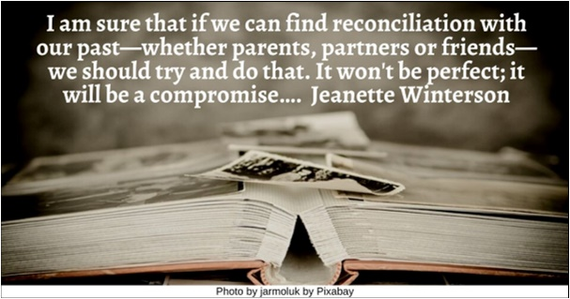

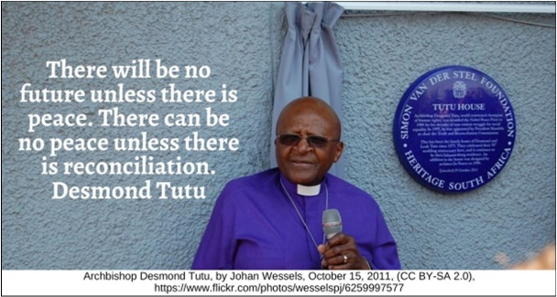

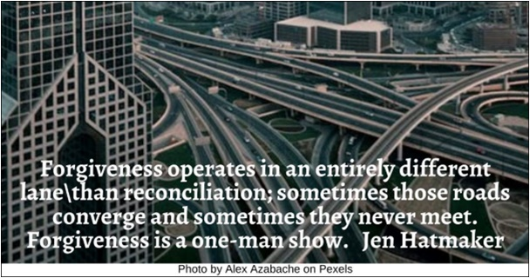



Smokescreen HRJ
Three Doors HRJ
Time HRJ
Truth HRJ

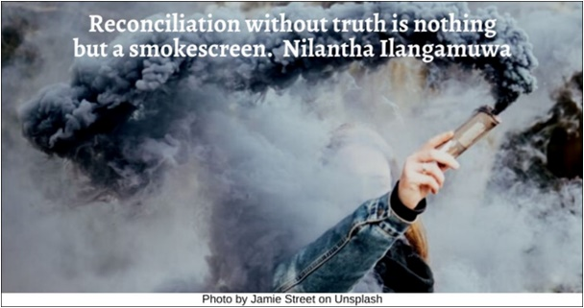

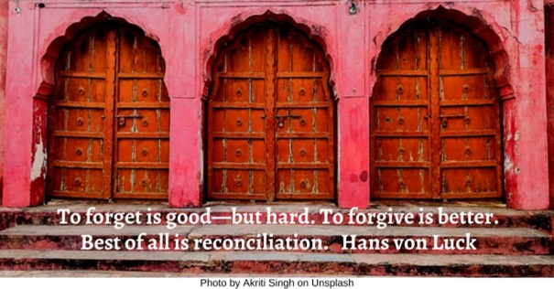

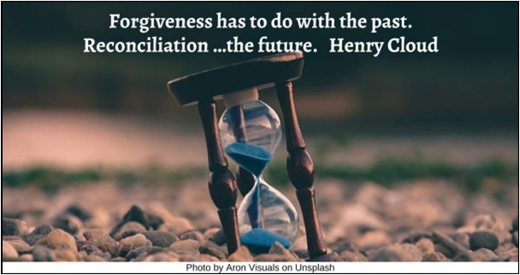

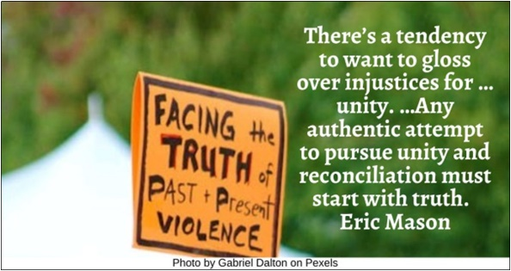
Unity HRJ
Upset HRJ
Wealth Old HRJ

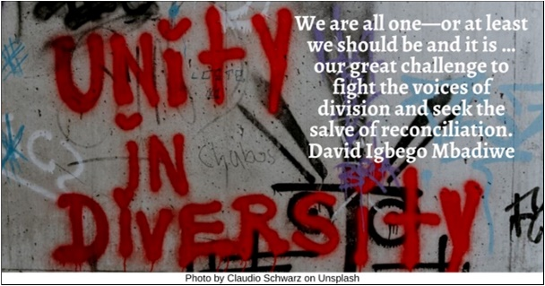



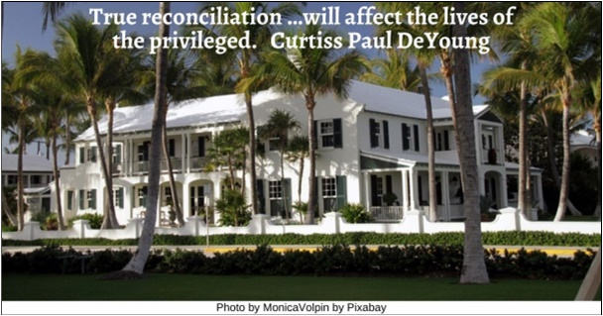

Text of Quotes
Black Lives Matter HRJ
When white people stop short of reconciliation, it's often because they are motivated by a deep need to believe in their own goodness…. Austin Channing Brown

Chalice HRJ
The process of reconciliation implies that people …should be prepared to reflect critically on their own religious tradition. David R. Smock

Church HRJ
The church offers the messy, inconvenient, gut-wrenching, never-ending work of healing and reconciliation. Rachel Held Evans

Civil Rights HRJ
We have been unwilling to commit to a process of truth and reconciliation in which people …give voice to …racial segregation, racial subordination, and marginalization. Bryan Stevenson

Couple HRJ
But reconciliation never came easy. Not with the things that mattered. Victor LaValle

Dove HRJ
Grace always invites rather than demands reconciliation. John Lynch

Equals HRJ
Reconciliation occurs between equals. Curtiss Paul DeYoung

Fewer Quarrels HRJ
If, in …a quarrel, each party declined to go more than 3/8 of the way, and if, in making friends, each was ready to go 5/8 of the way— …there would be more reconciliations than quarrels! Lewis Carroll

First Nations HRJ
Reconciliation for the powerful and privileged means trusting those who have lived under oppression and even following their lead…. Curtiss Paul DeYoung

Forgiveness HRJ
Forgiveness is mandatory; reconciliation is optional. Lysa TerKeurst

Hand Reaching HRJ
Those who love …know that love is not only a blinding flash, but also a …struggle in the darkness for the realization of …reconciliation. Albert Camus

Hands over Eyes HRJ
Denial is the way people handle what they cannot handle. Shannon Alder

Harbor HRJ
Layton once said that “a poet is deeply conflicted and it is in his work that he reconciles those deep conflicts. It doesn’t set the world in order, it doesn’t really change anything. It is just a kind of harbor, it’s the place of reconciliation….” Roger Housden

Homeless HRJ
My gut feeling says he needs a second chance. Like we all do. Mary Hanks

John Lewis HRJ
Leaders should always be the initiators of reconciliation. Adam LiVecchi

Journey HRJ
The journey toward healing begins with an awakening. Eric Mason

Martin Luther King Jr HRJ
The nonviolent approach …does something to the hearts and souls of those committed to it. …Finally, it reaches the opponent and so stirs his conscience that reconciliation becomes a reality. Martin Luther King Jr.
Meditation HRJ
The tranquility of the soul rests in one's reconciliation with the realities of life. B.S. Murthy
Photo by Oluremi Adebayo on Pexels

No HRJ
Sometimes the foundation of trust on which a relationship was built cannot be repaired. Harriet Lerner

Nonviolence HRJ
By appealing to conscience and …moral nature, nonviolence nurtures the atmosphere in which reconciliation and justice become actual possibilities. John Lewis

Old Photographs HRJ
I am sure that if we can find reconciliation with our past—whether parents, partners or friends—we should try and do that. It won't be perfect; it will be a compromise…. Jeanette Winterson

Reconciliation HRJ
There will be no future unless there is peace. There can be no peace unless there is reconciliation. Desmond Tutu

Roads HRJ
Forgiveness operates in an entirely different lane than reconciliation; sometimes those roads converge and sometimes they never meet. Forgiveness is a one-man show. Jen Hatmaker

Self-care HRJ
If we want to reconcile with our family or with friends who have hurt us, we have to take care of ourselves first. Thích Nhất Hạnh

Smokescreen HRJ
Reconciliation without truth is nothing but a smokescreen. Nilantha Ilangamuwa

Three Doors HRJ
To forget is good—but hard. To forgive is better. Best of all is reconciliation. Hans von Luck

Time HRJ
Forgiveness has to do with the past. Reconciliation …the future. Henry Cloud

Truth HRJ
There’s a tendency to want to gloss over injustices for …unity. …Any authentic attempt to pursue unity and reconciliation must start with truth. Eric Mason

Unity HRJ
We are all one—or at least we should be and it is …our great challenge to fight the voices of division and seek the salve of reconciliation. David Igbego Mbadiwe

Upset HRJ
Is an apology valid without change? If he says he’s sorry, but maintains he’s not guilty, doesn’t that resemble manipulation more than reconciliation? Chanel Miller

Wealth HRJ
True reconciliation …will affect the lives of the privileged. Curtiss Paul DeYoung

